- Solve the proportion. Show your work. $\frac{3}{x+1}$ = $\frac{5}{11}$

- The figures in each pair are similar. Find the value of each variable. Show your work.

- 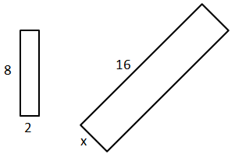

- 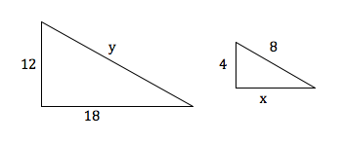

- Determine whether the triangles are similar. If so, write a similarity statement and name the postulate or the theorem you used. If not, explain.

- 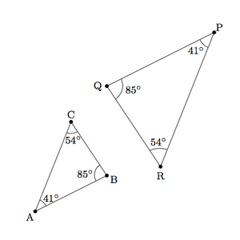

- 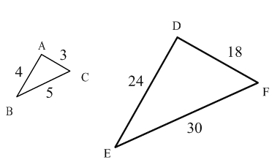

- Find the value of each variable for the right triangles. Make sure all answers are in reduced radical form. Show your work.

  - 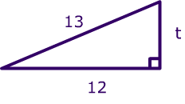
  - 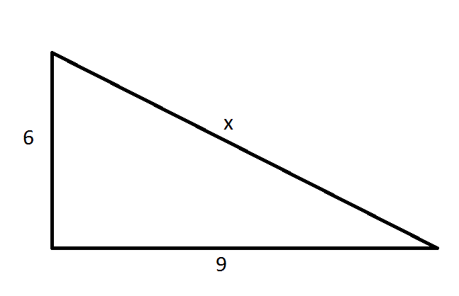

- Given the following triangle side lengths, identify the triangle as acute, right or obtuse. Show your work.

  - 5 in, 6 in, 7 in

  - 18 in, 9 in, 12 in

- Find the missing value. Show your work. Round to the nearest hundredth.

  - 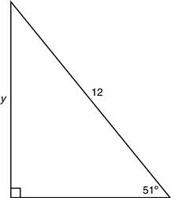

  - 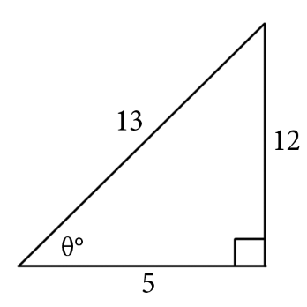

  - 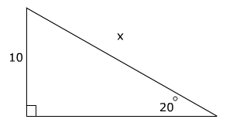

- Given the vertices of ∆ABC are A (2,-5), B (-4,6) and C (3,1), find the vertices following each of the transformations FROM THE ORIGINAL vertices:

  - R_{x = 3}

  - T_{<3,-6>}

  - r_{(90◦, o)}

- Find the congruence transformation that maps ∆ABC to ∆A’B’C’. Explain.
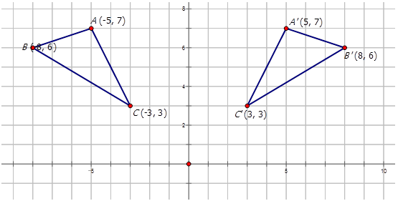

- Find the area of each figure to the nearest tenth.

  - 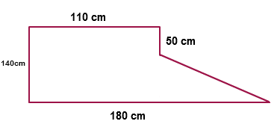

  - 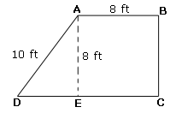

- Find the measure of both arc AB and arc APB, where <APB = 108◦. Please be sure to show your steps.
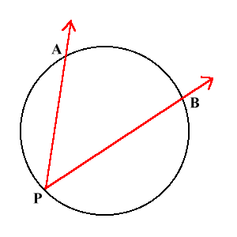

- Find the area of a regular Octagon with side lengths 5in. Round your answer to the nearest tenth.

- Find the surface area of each figure to the nearest tenth.

  - 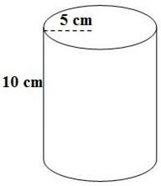 b. 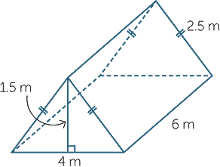

  - What is a real-world example or use of surface area?

- Find the surface area of each figure to the nearest tenth.

  - 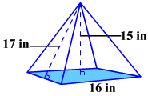

  - 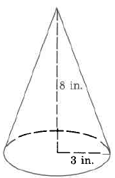

- Find the volume of each figure to the nearest tenth.

  - 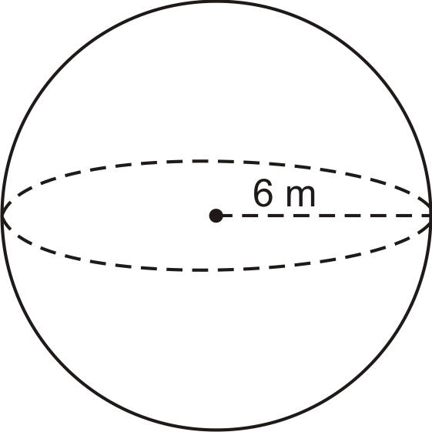

  - 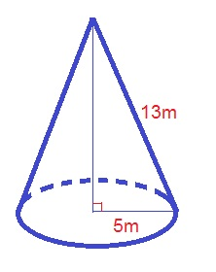

  - 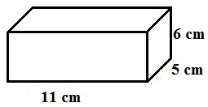

- Find the center and radius, then write the standard equation of each circle

  - 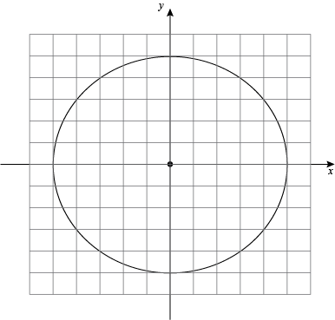

  - 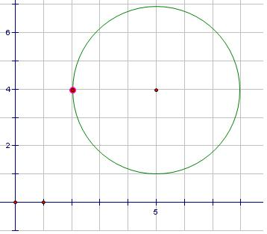

  - 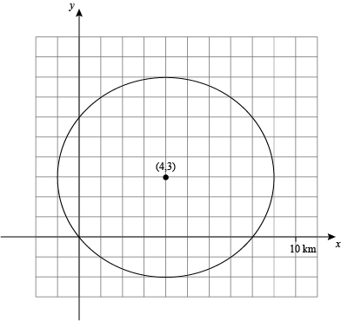

- Solve for x

  - 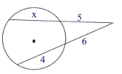

  - 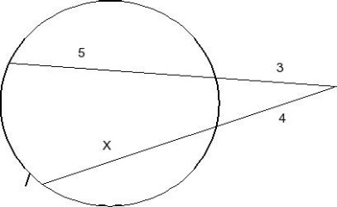

- Evaluate

  - 6!

  - ₈P₅

  - ₁₂C₄

- Use the spinner to find each theoretical probability
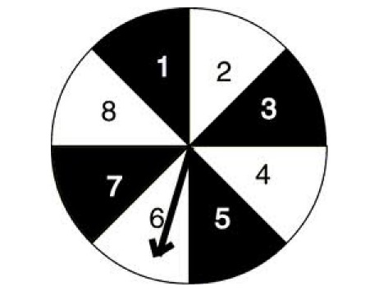
  - P (a number no more than 5)
  - P (an even number)
  - P (a number less than 3)

- You roll two standard number cubes. What is the probability that the sum is odd,
given than one of the number cubes shows a 4?

- What is the area of the figure:

